แบบฝึกที่ 1 เรื่องคำศัพท์กีฬาประเภทต่าง ๆ

Part A : Rewrite these words.

- i n b d a m t n o = _____________________________

- l f b a l o t o = _____________________________

- ojud = _____________________________

- b a e b s l k t a l = _____________________________

- l v e b y l o l a l = _____________________________

- l g o f = _____________________________

- w b o g l i n = _____________________________

- g m t n a s i c y = _____________________________

- e t n n s i = _____________________________

10. n g f i i s h = _____________________________

Name _____________________________ Class ___________ No. ___________
Part B : Write the name of these games.
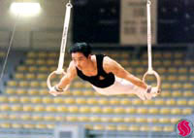
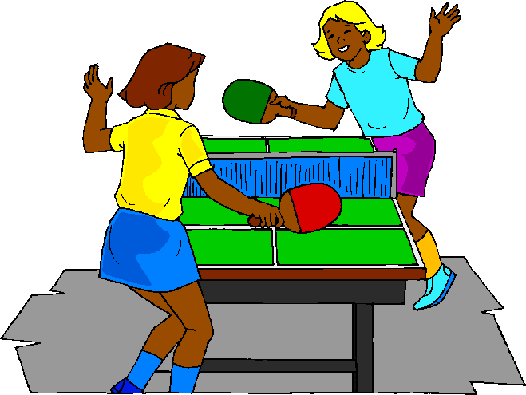

1. ___________________________ 2. _______________________
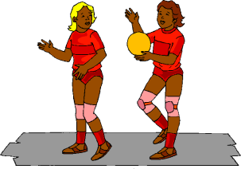
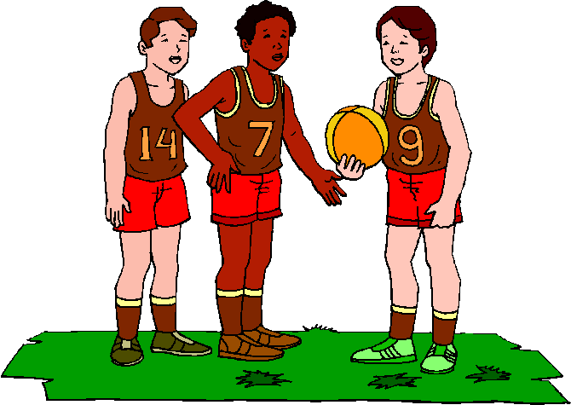

3. _____________________________ 4. _______________________
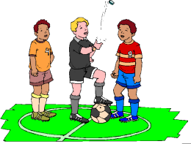

5.______________________ 6.______________________
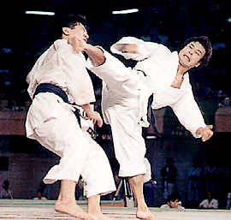
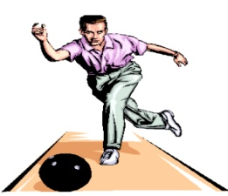

7.______________________ 8.______________________
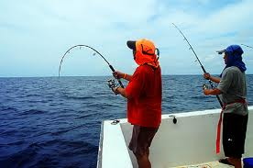
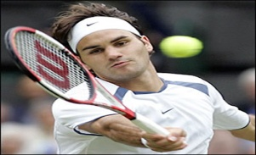

9.______________________ 10.______________________

Name _____________________________ Class ___________ No. ___________

