**ใบความรู้ที่ 2**

**Say the words.**

**Initial sounds**

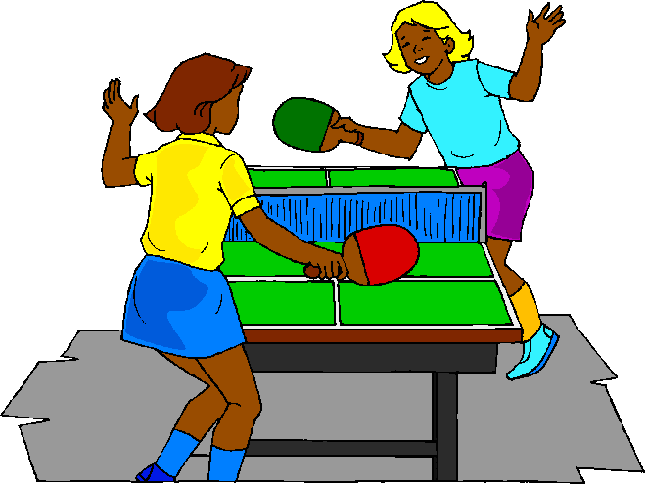MCj04381530000[1]

swim ping pong

**Final sounds**

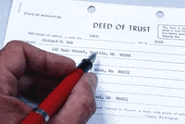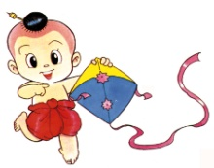

write kite

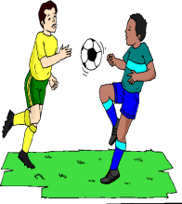Toon0342

fishing football

**Vowel sounds**

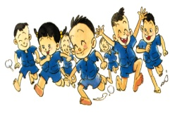

play basketball

Toons087 t*e*nnis

**GOOD LUCK**

